MARKET EQUILIBRIUM

Equilibrium means the point of rest or balance. Equilibrium refers to the market condition which, once achieved, tends to persist. In economics market equilibrium occurs when the quantity of a commodity demanded in the market per unit of time equals the quantity of the commodity supplied to the market over the same time period. Geometrically, equilibrium occurs at the intersection of the commodity’s market demand curve and market supply curve. The price and quantity at which equilibrium exists are known, respectively, as the equilibrium price and the equilibrium quantity.
Let us take a hypothetical market demand curve and a hypothetical market supply curve to discuss the concept of market equilibrium:

Market Demand Curve

8
7
6
5
4
3
2
1
0
.
.
.
1000 2000 3000 4000 5000 6000 7000 8000
P_{x}($)
D_{x}
QD_{x}
.
.
.
.
.
.
Demand Curve

Market Supply Curve
Supply Curve
S_{x}

Fig. 1.5
6

5

4

3

2

1

0
2000 4000 6000 8000
.
.
.
.
.
QS_{x}
P_{x} ($)

From the above market demand curve and the market supply curve, we can determine the equilibrium price and the equilibrium quantity for commodity X as shown in Table 1.1
Table 1.1
P_{x} ($)QD_{x}QS_{x}620008000530006000440004000350002000260000
Equilibrium

We see that when price of X is $4, the sellers will sell exactly the same quantity as the buyers will buy. So this is the equilibrium market price and equilibrium market quantity. If the price is higher than $4 as for example $5, the sellers would offer 6000 units of X while the buyers would buy only 3000 units. As a result, the sellers would possess an extra 3000 amount of unsold X. Therefore, they must lower the price to sell this excess amount of X.
On the other hand, if the price is less than $4 as for example $3, the buyers want to buy 5000 units of X while the sellers will offer only 2000 units of X. Therefore, there will be a group of unsatisfied buyers for whom the price must increase up to $4 so that the sellers may bring an increasing amount of X.
Market equilibrium may also be explained with the intersection of demand curve and supply curve. In the following Fig 1-1, the demand and supply curves meet at P. Hence PP © will be the market price ($4) because in this position demand and supply of X is equal (4000).

Q_{x}
.

P ©

6
5
4
3
2
1
0
2000 4000 6000 8000
P_{x}($)
D_{x}
.
.
.
.
.
.
.
.
S_{x}
p
Fig. 1-1

This is how market price is fixed and market equilibrium can be established.

Price Determination:

Equilibrium Price and Quantity:

For each economic good there is a supply schedule and a demand schedule. If the two are brought together we find that the quantity demanded and the quantity supplied will be equal at one and only one market price. This is the equilibrium price. The equilibrium price may be determined from the supply and demand schedules, or, as is more usually the case, from the point at which the demand and supply curves intersect. In Fig. 17.1 for example, the equilibrium price is 30p, for only at this price is the quantity brought to the market by willing sellers equal to the amount taken off the market by willing buyers.

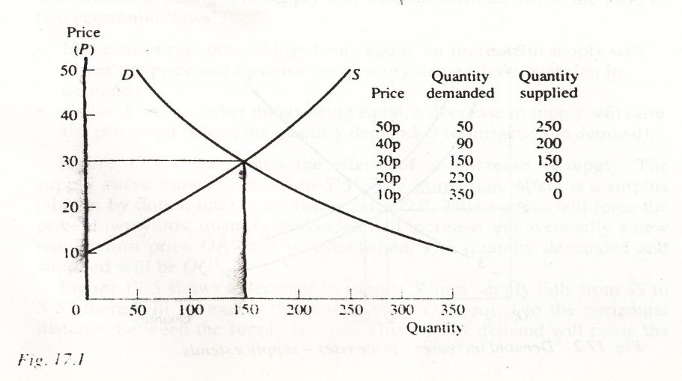

At prices higher than the market price (e.g. 40p) the quantity supplied will be greater than the quantity demanded and the excess supply would oblige sellers to lower their prices in order to dispose of their output. This situation is sometimes described as a buyers' market.
At prices lower than the market price (e.g. 20p) the quantity demanded will exceed the quantity supplied, giving rise to a shortage. Competition shortage of buyers will force up the price giving rise to a condition known as a sellers' market.

The equilibrium or market price is 30p, because at any other price there are market forces at work which tend to change the price.

Changes in equilibrium:
Market prices are determined by the interaction of demand and supply and in competitive markets chan^{g}es in market prices must be due to changes in demand or supply, or both. Price does not move independently of the demand and supply situations.
The effects of shifts in demand:

The effects of chan^{g}es in demand may be stated in terms of economic 'laws'.

- In the short run, other things being equal, an increase in demand will raise the price and increase the quantity supplied (extension in supply).

- In the short run, other thin^{g}s bein^{g} equal, a decrease in demand will lower the price and reduce the quantity supplied (contraction in supply).
These statements are generalizations based upon observations of human behavior, and since they indicate what happens in the great majority of cases they are described as laws. Figure 17.2 shows the effects of a change in demand.

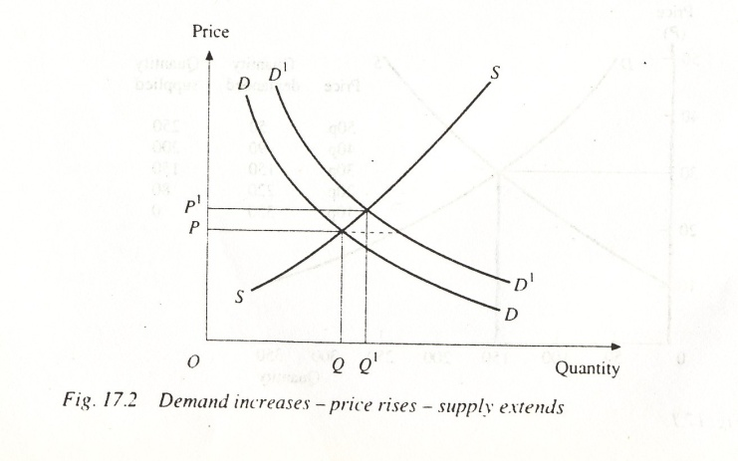

We can use Fig. 17.2 to explain the effects of an increase in demand by assuming that DD is the original demand curve so that the equilibrium price is OP and the quantity OQ is demanded and supplied. Assume that demand now increases from DD to D^{I}D'. The immediate effect is to cause a shortage (shown by dotted line) at the ruling price OP. This shortage will cause the price to be bid upwards and quantity supplied will increase until a new equilibrium price is established at OP'. The quantity demanded and supplied is now OQ¹.
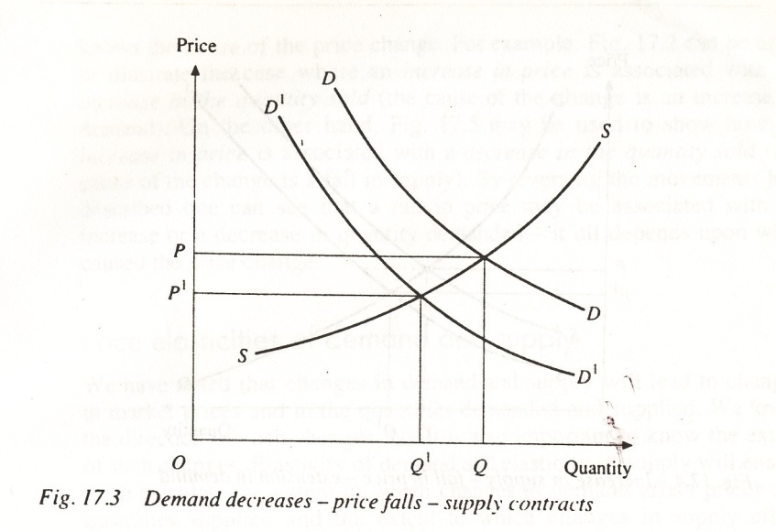
Figure 17.3 shows a decrease in demand. The demand curve shifts to the left (D'&). There is a surplus at price OP (equal to the horizontal distance between the demand curves). Suppliers will be obliged to lower prices in order to clear their stocks. This fall in price will tend to reduce the quantity supplied and increase the quantity demanded until a new and lower equilibrium price is established at OP'.

The effects of shifts in supply:

The effects of chan^{g}es in supply may also be summarized in the form of two economic 'laws'.
- In the short run, other things being equal, an increase in supply will lower the price and increase the quantity demanded (extension in demand).

- In the short run, other things being equal, a decrease in supply will raise
L-
the price and reduce the quantity demanded (contraction in demand).
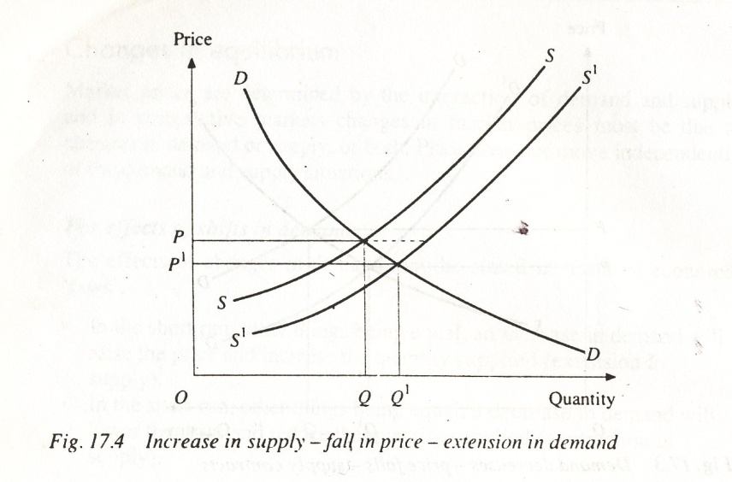

Figure 17.4 demonstrates the effects of an increase in supply. The supply curve moves from SS to S^{I}S^{I}. The immediate effect is a surplus (shown by dotted line) at the ruling price OP. This surplus will force the price downwards, quantity demanded will increase and eventually a new equilibrium price OP' will be established. The quantity demanded and supplied will be OQ¹

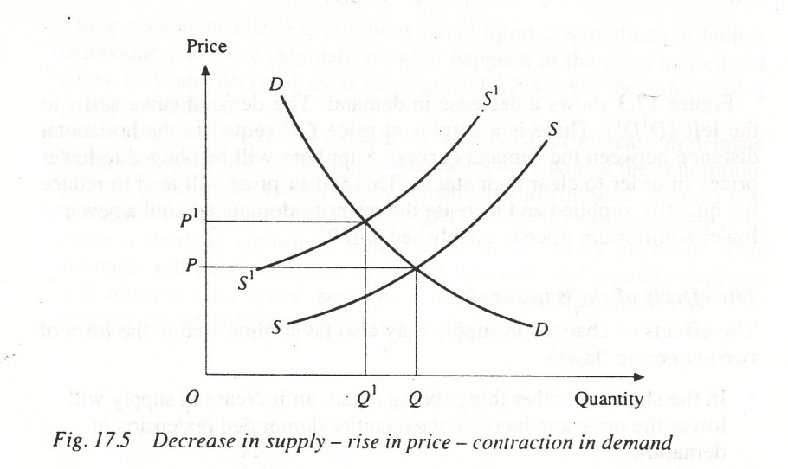

Figure 17.5 shows a decrease in supply. When supply falls from SS to ST there will be excess demand at price OP (equal to the horizontal distance between the supply curves). This exce^{s}s demand will cause the price to rise: quantity demanded will fall and quantity supplied will increase until a new equilibrium price is established at OP¹.

Problem – 1
From the following demand and supply functions calculate the equilibrium price and the equilibrium quantity. What will happen to the equilibrium price and quantity if government imposes a tax of TK. ⋅90 per unit? Graphically present the before and after situation in addition to the mathematical calculation.
QD_{x} = 4000 – 400P_{x}
QS_{x} = – 500 + 500P_{x}
Since we know that at equilibrium QD_{x} = QS_{x,}, we can Calculate the equilibrium Price and equilibrium quantity mathematically:
QD_{x} = QS_{x}
∴ 4000 – 400P_{x} = – 500 + 500P_{x}
or, 4500 = 900P_{x}
or, 900P_{x} = 4500
or, P_{x} = 5 (equilibrium price)
Substituting this equilibrium price either into the demand equation, or into the supply equation, we get the equilibrium quantity.
QD_{x} = 4000 – 400P_{x}
= 4000 – 400(5)
= 4000 – 2000
= 2000 (equilibrium quantity)
Now if government imposes a tax of TK. ⋅90 per unit, then the supply function of the supplier will be as fallows:
QS_{X}t = – 500 + 500 (P_{x} – t) (where t = per unit tax)
= – 500 + 500 (P_{x} – ⋅90)
= – 500 + 500P_{x} – 450
= – 950 + 500P_{x}
Therefore, after the imposition of tax, the new equilibrium Price will be
QD_{x} = QS_{x}t
∴ 4000 – 400P_{x} = – 950 + 500P_{x}
or, – 900P_{x} = – 4950
or, P_{x} = 5.5 (New equilibrium price)
Now, substituting this new equilibrium price either into the demand equation or into the supply equation, we get the new equilibrium quantity.
QD_{x} = 4000 – 400P_{x}
= 4000 – 400(5.5)
= 4000– 2200
= 1800 New equilibrium quantity.

1000 2000 3000 4000

10

9

8

7

6

5.5
5

4

3

2

1

0
S_{t}
S
D
Graphical presentation:
Supply Curve
Demand Curve
P

D
Q_{x}

Problem - 2
From the following demand and supply functions calculate the equilibrium price and the equilibrium quantity. What will happen to the equilibrium price and quantity if government gives (provides) a subsidy of TK. 2 per unit? Graphically present the before and after situation in addition to the mathematical calculation.
QD_{x} = 50 – 2P_{x}
QS_{x} = – 10 + 3P_{x}
Since we know that at equilibrium QD_{x} = QS_{x,}, we can calculate the equilibrium Price and the equilibrium quantity mathematically:
QD_{x} = QS_{x}
∴ 50– 2P_{x} = – 10 + 3P_{x}
or, 60 = 5P_{x}
or, 5P_{x} = 60
or, P_{x} = 12 (equilibrium price)
Substituting this equilibrium price either into the demand equation, or into the supply equation, we get the equilibrium quantity.
QD_{x} = 50 – 2P_{x}
= 50 – 2(12)
= 50 – 24
= 26 (equilibrium quantity)
Now, if government gives (provides) a subsidy of TK. 2 per unit, then the supply function of the supplier will be as follows:
QS_{xs} = – 10 + 3(P_{x}+2)
= – 10 + 3 P_{x}+ 6
= – 4 + 3 P_{x}
Therefore, after providing subsidy, the new equilibrium price and quantity will be
QD_{x} = QS_{xs}
or, 50 – 2P_{x} = – 4 + 3P_{x}
or, 54 = 5P_{x}
or, 5P_{x} = 54
or, P_{x} = 10.80
Now, substituting this new equilibrium price either into the demand equation or into the supply equation, we get the new equilibrium quantity.
QD_{x} = 50– 2P_{x}
= 50 – 2(10.80)
= 50– 21.60
= 28.40 (equilibrium quantity)
Graphical presentation:
q
– 10 – 4 0 10 20 30 40 50
25

20

15

12

10

5

S
S_{s}
E
E_{s}
P
Supply Curve
Demand Curve

PROBLEM:
From the following market demand function and market supply function determine the equilibrium price and the equilibrium quantity.
QD_{x} = 8000 – 1000OP_{x}
QS_{x} = 4000 + 2000P_{x}

Since we know that at equilibrium QD_{x} = QS_{x}, we can determine the equilibrium price and the equilibrium quantity mathematically:

QD_{x} = QS_{x}
8000 – 1000P_{x} = - 4000 + 2000P_{x}
12,000 = 3000P_{x}
P_{x} = $4 (equilibrium price)

Substituting this equilibrium price either into the demand equation or into the supply equation, we get the equilibrium quantity.
QD_{x} = 8000 – 1000(4) or QS_{x} = – 4000 + 2000(4)
= 8000 – 4000 = – 4000 + 8000
= 4000 (units of X) = 4000 (units of X)

Problem -3
From the following demand and supply functions calculate the equilibrium price and equilibrium level of output?
Qd = 36 – 4P
Qs = –12 + 12P

